**CHAPTER 2**

# **INTRODUCTION**

This chapter will concentrate on research that is important to this study, such as the specifics of the dataset for this study on selected Malaysian mammals. The study goes on to discuss machine learning and deep learning in further depth. Then it will go into the techniques, softwares and libraries that will be used in this research in greater depth. It will also go through any similar or comparable applications to this research. Finally, it will give the chapter's summary.

# **MAMMALS IN MALAYSIA**

Malaysia is home to a diverse range of animals. More than 200 species of mammals are thought to exist in Malaysia. Shrews, mice, and rats are among the smallest, while elephants and gaur, or seladang, are among the largest. Orangutans, bears, deers, and tigers are just a few of the common creatures found in Malaysia. Is there a particular location where we may discover these creatures? In the 130 million-year-old rainforests of Taman Negara, the national park, which is home to a wide variety of Malaysian wildlife, including elephants, monkeys, deer, hornbills, and lizards. The Mulu World Heritage Area comes next, and it is home to a 60 million-year-old rainforest that has become one of Southeast Asia's most popular natural attractions. The Sarawak Chamber, the world's largest underground chamber, and the Clear Water Cave, the world's longest network of caverns, are both found in the area.. In addition to gibbons, orangutans, hornbills, and Sumatran rhinoceroses, other Malaysian animal species exist.

## **Animals for research**

For this study, it will be specified on certain mammals only, such as elephants, sun bears, deers, tigers, and orangutans that may be the datasets for building an images recognition application. To be more detailed, this chapter will do research about those animals.

### **Malayan Tiger**

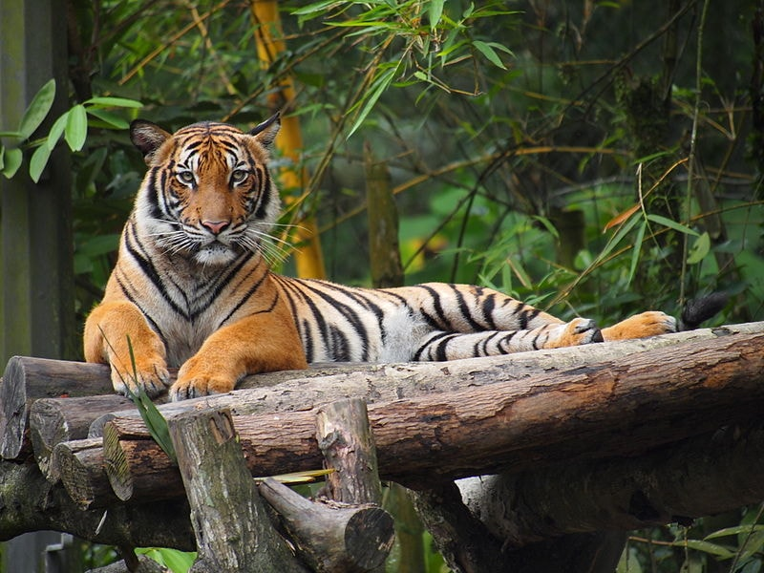

*Figure 2.1: Malayan Tiger*

Panthera tigris jacksoni is the scientific name for Malayan tigers. The term 'Jacksoni' alludes to a tiger environmentalist from the United Kingdom named Peter Jackson. This large cat belongs to the Felidae family and the Mammalia class. The Malaysian name for tiger is 'harimau,' or simply 'rimau.' This tiger is also known as Pak Belang, which means Uncle Stripes in English. The Malayan tiger is one of six tiger subspecies. The Siberian or Amur, Bengal, Sumatran, south China, and Indochinese tigers all belong to this group (AZ Animals, 2021).

The back, tail, head, and face of a Malayan tiger are orange with a black striped pattern. It has a white underside. Long whiskers and piercing golden eyes distinguish this large cat. The tongue of the Malayan tiger is coated with little flexible spikes known as papillae. Papillae are used to scrape the fur or feathers from the tiger's prey. This prevents the tiger from swallowing fur or feathers when eating. A male Malayan tiger may reach a length of eight feet from head to tail, while females can reach a length of seven feet. The male Malayan tiger weighs between 220 and 300 pounds, while the female is between 170 and 240 pounds. A 200-pound tiger is almost the same weight as an adult kangaroo. The Malayan tiger is the tiger's smallest subspecies on the mainland. When compared to the Siberian tiger, which may grow to reach 10.5 feet long and weigh up to 660 pounds, this tiger is small.

### **Elephant**

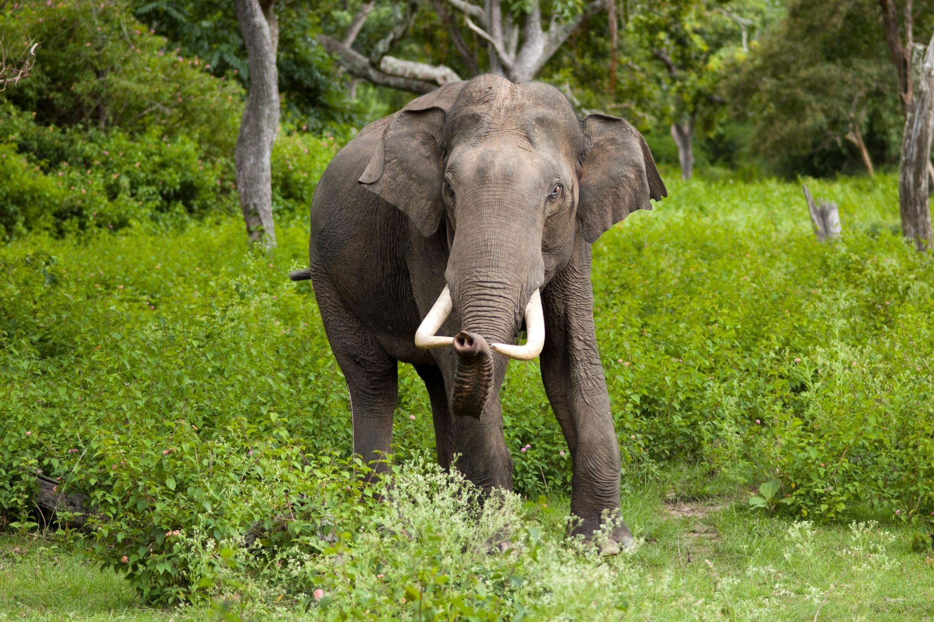

*Figure 2.2: Malayan Elephant*

Asian elephants and Bornean elephants are the two varieties of elephants that live in Malaysia. Aside from Malaysia, the Asian elephant is found in 13 Asian nations. Elephas maximus is the scientific name for Asian elephant. Several sub-species exist in various regions of the species' range. India, China, Vietnam, Myanmar, Thailand, Laos, Cambodia, and Malaysia are all home to the nominate subspecies of the Indian elephant (Elephas maximus indicus). On the Indonesian islands of Sumatra (E. m. sumatranus) and Borneo, there are two subspecies of Asian elephant (Othman, 2017).

For the Bornean elephant, it is claimed as the subspecies of the Asian elephant that mostly can be found in Malaysia's east coast of Sabah and Indonesia's northwestern Kalimantan. Based on Othman (2017), Bornean elephants are also the subspecies with the shortest distribution range of the four. Male Bornean elephants' heights range from 1.57 m to 3.64 m, with an average of 2.17 m, as assessed after transfer due to fighting. Females range in height from 1.45 to 2.26 meters, with an average of 1.96 meters.

### **Orang Utan**

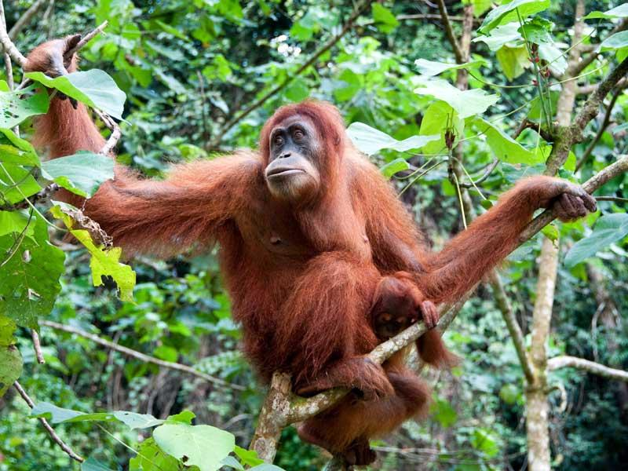

*Figure 2.3: Orangutan*

Only two Asian nations, Malaysia and Indonesia, are home to orangutans. Pongo is the scientific term for orangutans. Parts of Borneo in Malaysia are home to two Orangutan subspecies: P. pygmaeus pygmaeus and P. pygmaeus morio (Misato Hayashi, Fumito Kawakami, Rosimah Roslan, Nurhafizie M. Hapiszudin & Sabapathy Dharmalingam, 2018). Their habitat mostly can be found in forests with dense canopy cover, taller trees, and uniform height. Nest trees are chosen for a variety of reasons, including comfort and stability, as well as to escape predators, who play an important part in deciding and establishing nests. The number of nests with tighter tree heights is affected by the quality of the heterogeneous forest structure, which is chosen by orangutans (N L Auliah, M Maulana, O Onrizal, 2021). Orangutans make nests in palm trees, although they appear to prefer trees left inside monocultural farms, possibly because these trees are higher than neighboring oil palm plants and provide better view positions and protection. Additional helicopter surveys in 2008 confirmed the presence of orangutan nests in isolated forest patches within the oil palm landscapes of eastern Sabah: Sandakan Bay (eight patches confirmed), Sugut floodplain (nests in 15 patches), Beluran (nests in seven patches), and Lower Segama (nests in seven patches) (nests in 14 patches) (Marc Ancrenaz, Felicity Oram, Nardiyono Nardiyono, Muhammad Silmi, Marcie E. M. Jopony, Maria Voigt, Dave J. I. Seaman, Julie Sherman, Isabelle Lackman, Carl Traeholt, Serge A. Wich, Truly Santika, Matthew J. Struebig, Erik Meijaard, 2021).

### **Sun Bears**

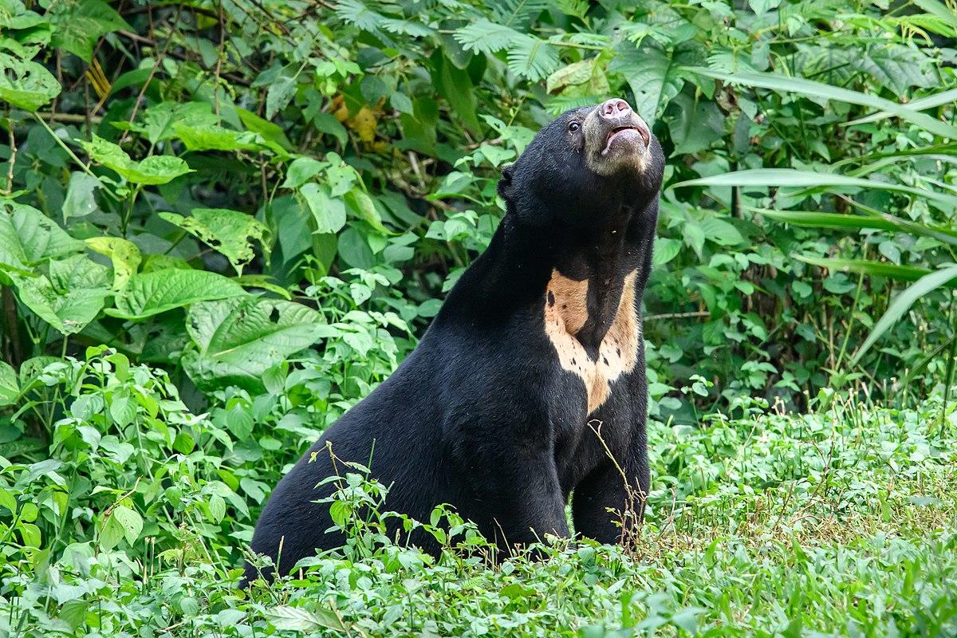

*Figure 2.4: Sun bear*

The sun bear, or Helarctos malayanus, is a big animal that lives in Southeast Asia's forests. Southeast Asia's Sumatra and Borneo islands are home to this species, which may be found all the way from Northeast India. 35–44 percent of current sun bear range is located in the insular area, which is usually regarded as their stronghold in terms of remaining stretches of unbroken forest (Mei-Hsiu Hwang,Mark A. Ditmer,Shu-De Teo,Siew Te Wong,David L. Garshelis, 2021). The Malayan sun bear is the Ursid family's smallest and least studied bear species (M Izzat-Husna, MS Mansor, N Nabilah, KZ Abidin, Z Kamarudin, R Topani, S Md Nor, 2021). The sun bear is known in Malaysia as beruang badu, or "honey bear," because of its fondness for honey. Insects like termites and millipedes as well as a wide array of fruits are all that they consume.

### **Deers**

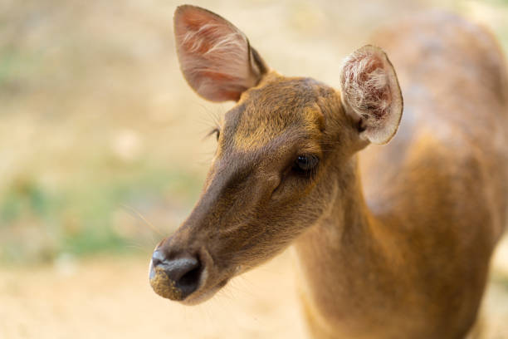

*Figure 2.5: Malayan deer*

Cervus nippon (sika), Cervus timorensis (rusa), and Cervus unicolor (sika) are all deer subspecies that may be found in Malaysia (sambar). Javan Rusa, Cervus timorensis, the male Javan rusa is larger than the female. Both sexes weigh an average of 152 kg. The antlers of males are shaped like a lyre and weigh around 2.5 kg each. This coat is greyish brown on both sexes. In terms of looks, they have large and broad ears. Because of their little legs, the animals seem to be stubby and elongated. The Javan rusa may be found mostly in the deciduous forests, plantations, and grasslands of the Southeast Asian islands. There are a lot of them on the edge of the woodland.

Everywhere in Asia, you'll find the Cervus unicolor (sambar). Three-tipped antlers from these animals are used to make knives and handles. Tigers, leopards, and crocodiles may easily feed on these animals, which occur in tropical seasonal woods. They stomp their hooves as a warning. The topsides of Sambars are covered in short, black hair, while the bottoms are covered in lighter brown to creamy white hair. As a signal, the tails of their bushy tails, which have white backsides and undersides, are raised. It is common for males to be larger and have a thicker mane around their necks than females. The antlers of male Sambars, which have three or four tines, are shed and regrow often. One set of antlers may reach a height of 100 cm. Men may weigh up to 185-260 kg, while women are limited to a maximum of 162 kg. Both mild and steep forested slopes are home to sambars, which may be seen in abundance.

# **MACHINE LEARNING**

When a system is able to learn and develop without being explicitly designed, it is known as machine learning (ML). Research into how to build computer programmes that can access data and figure things out for themselves is known as "machine learning. Supervised, Unsupervised, Semi-supervised, and Reinforcement Learning are all examples of machine languages.

## **Types of Machine Learning**

### **Supervised learning**

With the use of well-labelled training data, supervised learning may be used to teach computers to anticipate future events. Data that has already been labelled with the desired output is referred to as "labelled data." supervised machine learning systems may utilise labelled examples to apply what they've learned in the past to new data and predict future occurrences (D. Fumo, 2017). The learning technique uses a known training dataset to produce an inferred function that predicts output values. Eventually, the system will be able to provide goals for every new input. Allowing for the model to be reworked in the event of a mistake is another feature of a learning algorithm (expert.ai, 2020). There are several algorithms that are commonly used in supervised machine learning, including Nearest Neighbor, Naive Bayes, Decision Trees, Linear Regression, Support Vector Machines (SVM), and Neural Networks. Nearest Neighbor is one of the most widely used algorithms in supervised machine learning.

### **Unsupervised Learning**

Unsupervised Learning is a machine learning approach in which the model does not require the user's supervision. Instead, it enables the model to operate independently to uncover previously unnoticed patterns and information. It is mostly concerned with unlabeled information (D. Johnson, 2021). Unsupervised learning algorithms, as opposed to supervised learning, allow users to accomplish more sophisticated processing tasks. Unsupervised learning, on the other hand, might be more unpredictable than other natural learning approaches (D. Johnson, 2021). The goal of unsupervised learning is for the algorithms to find patterns in the training data sets and categorise the input items based on the patterns found by the system (Mary K. Pratt, 2020). The algorithms examine the datasets underlying structure in order to extract meaningful information or characteristics. As a result, these algorithms should be able to generate specified outputs from unstructured inputs by looking for connections between each sample or input item. Using animals as an example, datasets including animal photographs might be presented to algorithms. The algorithms may then divide the creatures into groups such as fur, scales, and feathers. As it learns to recognise distinctions within each category, it may categorise the photos into even more specific subgroups (Mary K. Pratt, 2020). Anomaly detection, neural networks, k-means clustering, and Association Rules are examples of unsupervised learning techniques.

### **Semi-supervised Learning**

Semi-supervised machine learning algorithms fall somewhere in the between of supervised and unsupervised learning since they utilise both labelled and unlabeled data for training. This approach has the potential to dramatically improve the accuracy of learning in systems that use it. To train/learn from labelled data, semi-supervised learning is typically employed, which requires the utilisation of competent and adequate resources. In contrast, obtaining unlabeled data often requires no additional expenditures (D. Fumo, 2017).

### **Reinforcement Learning**

When a computer programme is taught to make a succession of correct or incorrect decisions, this process is known as "reinforcement learning." The agent learns to accomplish a goal in an environment that is both unpredictable and potentially challenging. Reinforcement learning brings an AI up against a game-like situation. To solve the issue, the computer performs a process known as "trial and error." For the actions it performs, artificial intelligence is rewarded or punished based on the wishes of the programmer. As much as feasible, it aims to raise the total reward (B. Osiski, K. Budek, 2018). Many techniques in reinforcement machine learning fall under the umbrella term "Q-Learning," "TD," and "Deep Adversarial Networks."

# **DEEP LEARNING TECHNIQUES**

## **Convolutional Neural Networks (CNN)**

Image classification and segmentation are key uses of convolutional neural networks (CNNs), neural networks with one or more convolutional layers (C. Thomas, 2019). In order to manage rising degrees of complexity and data pretreatment and compilation, it is created. CNNs are one of the most adaptable models for focusing on both image and non-image input (P. Vadapalli, 2020).

One layer of input neurons is used for interpreting primary visual data, such as pixels in a picture, and a single layer of output neurons is used in some CNNs to analyse images on their inputs via distributed linked convolutional layers. A third layer, known as the "sample layer," is present in CNNs to limit the number of neurons engaged at each level. Linking layers between the sample and output layers is a common feature in CNNs (P. Vadapalli, 2020).

The convolutional model is developed in four phases when the input data is imported into the convolutional model: Following the convolution process, a function is applied to the feature maps generated from the input data. Then, CNN uses a technique called Max-Pooling, which helps the network discover images based on alterations. After that, the data is flattened for CNN analysis, which follows the Flattening phase. Also known as "the hidden layer," the Full Connection calculates a loss function for a model (P. Vadapalli, 2020).

## **Recurrent Neural Networks (RNNs)**

RNNs are a kind of artificial neural network that are especially built to deal with time series data or data that includes sequences. Neural networks intended for unrelated data are called feed-forward neural networks. But if one data point relies on the previous data point, the neural network must be adjusted to account for the dependencies. Memory is a property of RNNs, allowing them to use previous inputs to build the next output in the sequence (Mehreen Saeed, 2021). To tackle an issue, there are two RNN designs that may be employed. One is Gated RNNs and the other is Long Short-Term Memory (LSTMs). Temporal data may benefit from LSTMs trained on memories. The three gates are Input, Output, and Forget. Memory-based data prediction of temporal sequences is also a strong suit of gated RNNs. The two gates are called "Update" and "Reset" (P. Vadapalli, 2020).

## **Generative Adversarial Networks**

An unsupervised machine learning task called generative modelling involves discovering and learning regularities or patterns in incoming data such that the model may be used to generate or output new instances that might have been taken from the original dataset (J. Brownlee, 2019). It's a cross between a Generator and a Discriminator, two deep learning neural network approaches. To discriminate between real and fake data, the Discriminator is used in conjunction with the Generator Network. In order for both networks to remain competitive, the Generator and Discriminator must continue to create and recognise both real and fake data. If an image library is necessary, the Generator network will create simulation results based on the real images. After that, a deconvolution neural network would be built (P. Vadapalli, 2020).

## **Comparison between deep learning techniques**

*Table 2.1: Comparison between deep learning techniques*

|  |  |  |
| --- | --- | --- |
| **Convolutional neural networks (CNNs)** | **Recurrent neural network (RNN)** | **Generative Adversarial Networks** |
| Works best in:   * Image recognition * Image analysing * Image segmentation * Video analysis * Natural language processing | Works best in:   * Image classification. * Image captioning that includes several words from a single image. * Sentiment Analysis. * Video classification. | Works best in:   * Image and Text Generation * Image Enhancement * New Drug Discovery processes |

Based on Table 2.1, the deep learning that will be used in this research is the Convolutional Neural Networks (CNN) because of its high accuracy in Image recognition. It is because CNN follows a hierarchical architecture that builds a network, like a funnel, and eventually produces a fully connected layer where all the neurons are linked to each other, and the output is processed.

# **METHODS**

## **Image Classification**

Images may be classified using a variety of criteria, such as the number of pixels or vectors in a certain area. Spectral or textural characterizations may be utilised in conjunction with the categorization legislation. Techniques for image categorization may be classified as either supervised or unsupervised (G. Boesch, 2021). It takes two steps to classify photos. Machine learning methods may then be used to categorise images into particular groups or classes based on the visual qualities extracted from the image data in the first stage (Nisar, Khalid, 2018). An algorithm's capacity to extract hidden information from a collection of structured and unstructured samples is a key benefit of machine learning for picture recognition (Supervised Learning). When it comes to artificial intelligence (AI), deep learning is the most frequent method (G. Boesch, 2021). Deep learning, along with sophisticated AI and GPU technologies, has made it feasible to achieve exceptional performance on photo classification tasks. Therefore, deep learning algorithms have reached human-level performance and real-time object detection in the whole area of picture recognition, face identification and image classification methods (G. Boesch, 2021).

## **Object Detection**

It is a common job in computer vision to identify and locate specified types of items in a picture. For determining the location of an object, you may either create a box around it or identify every pixel in the picture that includes it (called segmentation) (P. Ganesh, 2019).

### **Two-Step Object Detection**

After detecting bounding boxes that may contain objects, two-step object detection categorises each bounding box as an individual item. In the beginning, a Region Proposal Network is needed to give a number of regions that are then transferred to typical DL-based categorization structures. For these region proposal networks, there are many various approaches, from the hierarchical grouping algorithm (which is very slow) to the CNN and ROI pooling and anchoring in Fast RCNNs (which are much faster) to training end-to-end with the use of these techniques (RPNs) (P. Ganesh, 2019).

## **One-Step Object Detection**

When it comes to real-time object detection, several one-step object detection architectures have been proposed, such as YOLO and its variants YOLOv2, SSD, and RetinaNet. These designs try to integrate the detection and classification stages. Regression's bounding box prediction was one of these algorithms' most remarkable accomplishments. It's considerably simpler to integrate detection and classification processes if each bounding box can be easily represented with a few values (for example, xmin, xmax, ymin, and ymax) (P. Ganesh, 2019).

### **Heatmap-based Object Detection**

In some aspects, heatmap-based object detection may be seen as an extension of one-shot object detection. In contrast to one-shot object identification approaches, heatmap-based object detection provides a probability distribution of the corners and centres of the bounding box. Based on the position of these corner/centre peaks in the heatmaps, bounding boxes may be predicted. Because each class may be represented by its own heatmap, this strategy integrates detection and classification into one. Heatmap-based object identification is now at the forefront of new research, although its processing time is still much slower than that of standard one-shot detection methods. There are several reasons why this is the case, including the fact that these algorithms need more complex backbone structures (CNNs) (P. Ganesh, 2019).

## **Geolocation**

GPS, mobile phone towers, WiFi access points, or a mix of these may be used to track a device's position. Using positioning systems, geolocation is able to trace an individual's whereabouts down to latitude and longitude coordinates, or, more realistically, a physical address. Geolocation may be used on both mobile and desktop devices (J. Frakenfield, 2021). An Internet-connected device's geolocation (both longitudinally and latitudinally) is referred to as geolocation. Rather than tracking your exact position, this means that it uses the device's location as a guide. As an example, let's look at the following: You lock your phone in the trunk of your vehicle as you walk your dog in the park. As long as your phone is in the car with you, you won't be geolocated (B. Boeckmann, 2020). Geolocation is especially useful when applied to financial services such as payments, banking, delivering food and cab. For Android devices, Google's Location Services API is a better option since it is simpler to use and gives better accuracy while using less power with the android.location package. With Google's Location Services API it can locate the user's location using GPS, Wi-Fi, Cell ID, or A-GPS, monitor user movement and respond to these changes with alerts or other actions, and estimate the distance to specified sites such as shops or cafés, which may be used to build up geofences. (virtual fence or perimeter around a physical location).

### **Comparisons**

*Table 2.2: Comparison between image classification and object detection*

|  |  |
| --- | --- |
| **Image Classification** | **Object Detection** |
| * An image classification approach may be categorised as parametric or non-parametric or hard or soft. * Preparation of images and choice of classification method are all steps in the image classification process. Finally, the total accuracy is assessed after each step has been completed and a classification system has been selected. An image of a certain item, like a rabbit in a picture, is often used as an input, and the predicted classes that define and match the object are the outputs. * **Disadvantage:** Unsupervised and supervised image classification methods have their drawbacks, which include lengthy training periods and inability to handle large datasets. | * Object detection is the process of locating items in an image and classifying them according to their characteristics, such as colour, shape, or size. It is possible to categorise natural photos using object detection as a method for locating specific instances of objects that fall into one of a variety of predetermined categories. * Image and video processing systems using this approach have been able to find certain types of things, such as automobiles or humans or animals or birds, by using this technique. Face recognition, pedestrian detection, vehicle detection, traffic sign detection, and video surveillance are just a few examples of how it may be put to use in the real world. * **Disadvantage:** Object detection has been greatly improved in a controlled setting in recent years. However, when items are put at random positions in a crowded and obstructed environment, the issue remains unresolved. |

Based on Table 2.2, the methods that will be used in this research is the image classification because using image as the input for the animal recognition is more convenient using Convolutional Neural Networks.Another method that will be used is the geolocation method to get the user’s and zoo location.

# **SOFTWARE FOR DEVELOPMENT**

## **Android Studio**



*Figure 2.6: Android Studio*

Android Studio is a specialised IDE for Android app development that was created by Google themselves. This programme is built on top of IntelliJ IDEA, a Java integrated development environment. Android Studio employs a Gradle-based build system, an emulator, code templates, and Github integration to facilitate Android application development. There are one or more modalities in Android Studio for every project. Modules for Android apps, Library modules, and Google App Engine modules are all examples of this kind of technology.

## **Flutter**



*Figure 2.7: Flutter*

An open source mobile UI framework developed by Google that was published in May 2017 is known as Flutter. With Flutter, we can construct a native mobile app from scratch using only one codebase. As a result, we may design two distinct applications with only one set of code and one set of tools for iOS and Android. With a Software Development Kit (SDK), you'll have all the tools you need to create your own Flutter-based apps. Compilation tools are included in this package (code for iOS and Android). Additionally, it includes a Framework (UI Library based on widgets), a collection of premade UI components that may be customised for your own purposes. Using Dart, a programming language developed by Google in October 2011, Flutter is able to run on a variety of devices.

## **React Native**



*Figure 2.8: React Native*

As a JavaScript framework, React Native enables developers to create actual, natively produced mobile apps for iOS and Android. Rather than being aimed at desktop computers, React Mobile is a JavaScript library for creating user interfaces for mobile devices. Web developers now also can create native-looking mobile apps using the JavaScript library that you already know and love. React Native also makes it simple to create for both Android and iOS at the same time since much of the code you write can be shared across platforms. In 2015, Facebook published the open-source React Native project. Within a few years, it has become one of the most popular mobile development tools in the industry. Popular mobile applications like Instagram, Facebook, and Skype all employ React Native development. This page goes into further detail about these and other React Native-powered applications.

## **Comparisons**

*Table 2.3: Comparison between software development*

|  |  |  |  |
| --- | --- | --- | --- |
|  | **Android Studio** | **Flutter** | **React Native** |
| **Developers** | Google | Google | Facebook |
| **Language** | Java | Dart | Javascript |
| **Type** | Native app | Hybrid app | Hybrid app |
| **Performance** | Fast | Fast | Close to Native |
| **Codebase** | Distinct repositories for each platform | Single cross-platform codebase | Single cross-platform codebase |
| **Pace development** | Slow | Fast | Fast |

The platform that will be used is the android studio because of the convenience to integrate model into the application by using Tensorflow lite library. A high-level API makes it easier to get raw data into the form the model needs, and to read the model's output. This reduces the amount of boilerplate code that must be written.

# **LIBRARIES FOR IMAGE RECOGNITION**

## **Tensorflow**



*Figure 2.9: Tensorflow*

TensorFlow, an open source toolkit for numerical computing and large-scale machine learning, was developed by the Google Brain team. Using a common concept, TensorFlow brings together a variety of machine learning and deep learning (also known as neural networking) models and methods. As a front-end Python API, it makes it easy to construct apps using the framework, while the framework itself executes the programmes in fast C++.

## **Matplotlib**

When it comes to charting data, Python's Matplotlib is one of the best options out there. John D. Hunter, the man of Matplotlib, made it open source so that everyone might benefit from it. The majority of Matplotlib is written in Python, with a few pieces in C, Objective-C, and Javascript included for backward compatibility with other platforms.

## **Opencv**



*Figure 2.10: Opencv*

This massive open source library for computer vision, machine learning, and image processing is currently playing a big part in real-time operation, which is very vital in today's systems. Images and videos may be processed using it to identify objects, faces, or even handwriting of a person. NumPy, for example, allows Python to parse the OpenCV array structure for analysis. We employ vector space and execute mathematical operations on these features to identify visual patterns and their varied characteristics.

# **SIMILAR APPLICATIONS**

## **Details about similar applications**

### **Seek By iNaturalist**

Seek by iNaturalist is a nature identification tool that makes use of picture recognition technologies. There are hundreds of species of plants, animals, birds, and fish that you may learn about with this app. In order to create this software, we worked with a team of professionals. People who like learning about the world will find all they need here. Search by iNaturalist lets you identify animals, learn about creatures, and more from anywhere in the world. More than 10 million species may be found in the app's database, which you can quickly browse.

### **Picture Insect: Bug Identifier**

Glority LLC created Picture Insect - Insect ID Pro, a freemium educational software for kids of all ages available for iOS and Android smartphones. You can rapidly learn the names of insects with the aid of this app so that you may better appreciate the wonders of the insect world. In order to begin learning, you only need to aim your camera towards an insect. It is able to identify more than a thousand different kinds of bugs. More than 90 distinct categories make up the massive collection. Insects are found in every category, and fresh findings are released every day. Besides insects, Picture Insect also includes information on birds and a wide variety of other animals.

### **SnakeSnap**

Unknown snakes may be identified using SnakeSnap, a smartphone app. To help you learn more about snakes, this app utilises visual identification to assist you identify them. With the support of snake aficionados, the programme has been designed to precisely and comprehensively provide all necessary services. It is the ultimate goal of this application to provide a complete application that teaches everyone how to live in harmony with fantastical beings of the imagination.

## **Comparisons**

*Table 2.4: Comparison between similar application*

|  |  |  |  |
| --- | --- | --- | --- |
|  | **Seek** | **Picture Insect** | **SnakeSnap** |
| **Platform** | Android and iOS | Android and iOS | Android and iOS |
| **Recognize** | More than 10 million species consist of plants, animals, birds, fish, etc. | More than 90 distinct categories of insects | Variety types of snake |

# **SUMMARY**

To summarise this chapter, we can say that it has covered study topics such as datasets that will be utilised for the system or application, techniques and software that may be used for the system, as well as other research fields. It also reviewed applications that are comparable to the programme that I want to develop and provided some suggestions on how to construct the image recognition application.

# **REFERENCES**

Malayan tiger. (2021, February 15). AZ Animals. https://a-z-animals.com/animals/malayan-tiger/

Behaviour and Spatial Ecology of the Bornean elephant (Elephas maximus borneensis) in Lower Kinabatangan, Sabah, Malaysia Borne. Nurzhafarina binti Othman (2017, September). https://www.wildlife.gov.my/images/document/penerbitan/kertas_maklumat/elephant.pdf

Importance of small forest fragments in agricultural landscapes for maintaining orangutan Metapopulations. (n.d.). Frontiers. https://www.frontiersin.org/articles/10.3389/ffgc.2021.560944/full

Hayashi M, Kawakami F, Roslan R, Hapiszudin N, Dharmalingam S. (2018). Behavioral studies and veterinary management of orangutans at Bukit Merah Orang Utan Island, Perak, Malaysia. https://link.springer.com/article/10.1007%2Fs10329-018-0650-2

Andrew B.Davies, FelicityOram, MarcAncrenaz, Gregory P.Asner. (n.d.). Combining behavioural and LiDAR data to reveal relationships between canopy structure and orangutan nest site selection in disturbed forests. ScienceDirect.com | Science, health and medical journals, full text articles and books. https://www.sciencedirect.com/science/article/abs/pii/S0006320718312576

Auliah, N. L., Maulana, M. I., & Onrizal, O. (2021, June). Habitat fragmentation effect on the characteristics of orangutan nest tree selection. In IOP Conference Series: Earth and Environmental Science (Vol. 782, No. 3, p. 032016). IOP Publishing.

Hwang, M.-H., M. A. Ditmer, S.-D. Teo, S. T. Wong, and D. L. Garshelis. 2021. Sun bears use 14-year-oldpreviously logged forest more than primary forest in Sabah, Malaysia. Ecosphere 12(10):e03769. https://esajournals.onlinelibrary.wiley.com/doi/full/10.1002/ecs2.3769

Muhammad Izzat-Husna, Mohammad Saiful Mansor, Noor Nabilah, Kamaruddin Zainul Abidin, Zubaidah Kamarudin, Rahmat Topani, Shukor Md Nor. (2021). Behavior patterns of captive malayan sun bears (Helarctos malayanus) at a rehabilitation center in peninsular Malaysia. ScienceDirect.com | Science, health and medical journals, full text articles and books. https://www.sciencedirect.com/science/article/pii/S1558787821000186

David C. Lee, Victoria J. Powell, Jeremy A. Lindsell. (2019). Understanding landscape and plot-scale habitat utilisation by malayan sun bear (Helarctos malayanus) in degraded lowland forest. ScienceDirect.com | Science, health and medical journals, full text articles and books. https://www.sciencedirect.com/science/article/abs/pii/S1146609X18303023

El-Jaafari, H.A., Panandam, J.M., Idris, I.B., & Siraj, S.S. (2008). RAPD Analysis of Three Deer Species in Malaysia. Asian-australasian Journal of Animal Sciences, 21, 1233-1237. https://www.semanticscholar.org/paper/RAPD-Analysis-of-Three-Deer-Species-in-Malaysia-El-Jaafari-Panandam/01c30d3b340b64ba0f5473321840b5a47a4975fa

Fumo, D. (2017, August 17). Types of machine learning algorithms you should know. Medium. https://towardsdatascience.com/types-of-machine-learning-algorithms-you-should-know-953a08248861

What is the definition of machine learning? (2021, May 26). Expert.ai. https://www.expert.ai/blog/machine-learning-definition/

Rungta, K. (2021, October 6). Unsupervised machine learning: What is, algorithms, example. Meet Guru99 - Free Training Tutorials & Video for IT Courses. https://www.guru99.com/unsupervised-machine-learning.html

Mary K. Pratt. (2020, July 8). What is unsupervised learning? SearchEnterpriseAI. https://searchenterpriseai.techtarget.com/definition/unsupervised-learning

Błażej Osiński, Konrad Budek. (2021, January 5). What is reinforcement learning? The complete guide. deepsense.ai. https://deepsense.ai/what-is-reinforcement-learning-the-complete-guide/

Boesch, G. (2021, August 24). A complete guide to image classification in 2021. viso.ai. https://viso.ai/computer-vision/image-classification/

Ganesh, P. (2019, October 7). Object detection : Simplified. Medium. https://towardsdatascience.com/object-detection-simplified-e07aa3830954

Vadapalli, P. (2021, December 8). Top 10 deep learning techniques you should know about. upGrad blog. https://www.upgrad.com/blog/top-deep-learning-techniques-you-should-know-about/

Christopher Thomas BSc Hons. MIAP. (2019, May 27). An introduction to Convolutional neural networks. Medium. https://towardsdatascience.com/an-introduction-to-convolutional-neural-networks-eb0b60b58fd7

What is Android studio? - Definition from WhatIs.com. (2018, October 9). SearchMobileComputing. https://searchmobilecomputing.techtarget.com/definition/Android-Studio

Android studio. (n.d.). www.javatpoint.com. https://www.javatpoint.com/android-studio

Thomas, G. (2021, July 9). What is flutter and why you should learn it in 2020. freeCodeCamp.org. https://www.freecodecamp.org/news/what-is-flutter-and-why-you-should-learn-it-in-2020/

S.A., N. (n.d.). What is react native? Complex guide for 2021. Custom Software Development | Netguru. https://www.netguru.com/glossary/react-native

Yegulalp, S. (n.d.). What is TensorFlow? The machine learning library explained. InfoWorld. https://www.infoworld.com/article/3278008/what-is-tensorflow-the-machine-learning-library-explained.html

What is scikit-learn? (n.d.). Codecademy. https://www.codecademy.com/article/scikit-learn

OpenCV - Overview - GeeksforGeeks. (2021, August 5). GeeksforGeeks. https://www.geeksforgeeks.org/opencv-overview/

Seek by iNaturalist alternatives. (n.d.). Top Best Alternatives – Crowdsourced Software Recommendation Engine. <https://www.topbestalternatives.com/seek-by-inaturalist/>

Boeckmann, B. (2020, October 22). *What is Geolocation?* SingleMind. <https://www.singlemindconsulting.com/blog/what-is-geolocation/>

Frankenfield, J. (n.d.). Geolocation definition. Investopedia. https://www.investopedia.com/terms/g/geolocation.asp